Inventory Item
This is a record for something you stock and sell. Track the amount and value you have on hand, as well as the marginal profit you make.
Using this type of item record requires the Inventory feature.
As you buy and sell inventory, your Cost of Goods Sold (COGS), income, and asset accounts are updated. Item profits are reflected on your income statement.
Step 1: Inventory Item creation: - Navigate to Lists->Accounting->Items->New
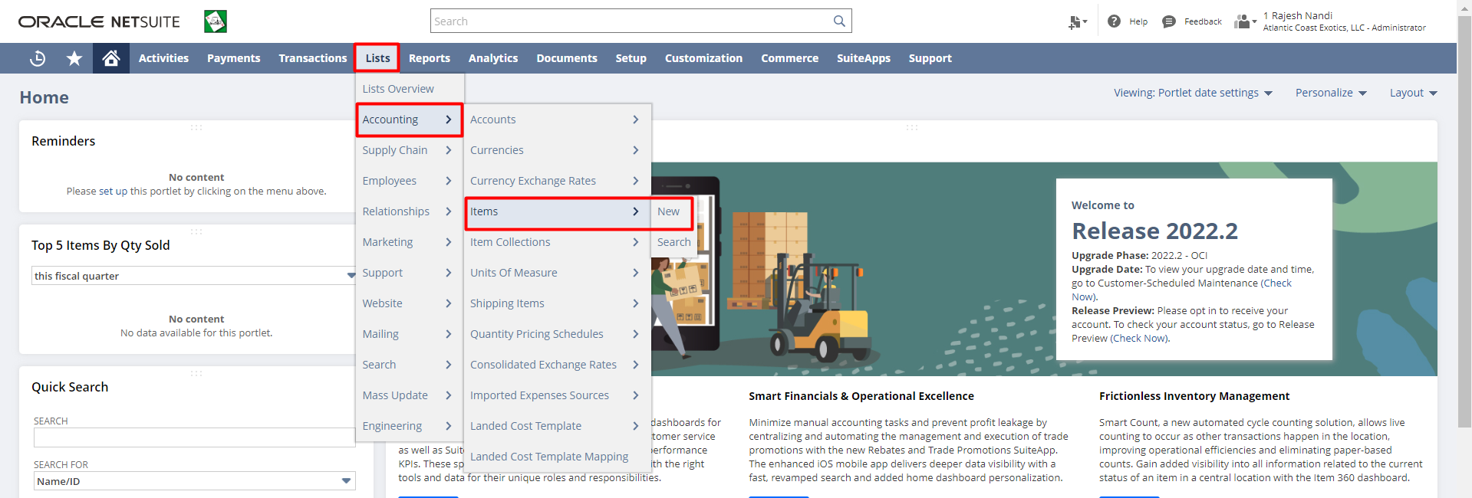

Step 2: Click on Inventory Item.
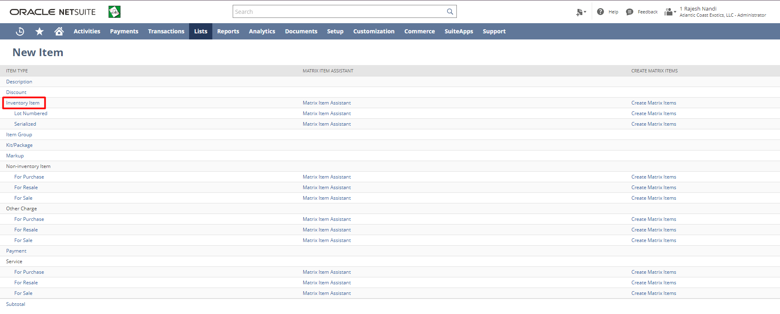

Step 3: Fill in the required details for the Inventory Item. Mandatory fields -Item Name/Number, Tax Schedule under Accounting subtab and put COGS, ASSET, INCOME Account. Put the other necessary details.
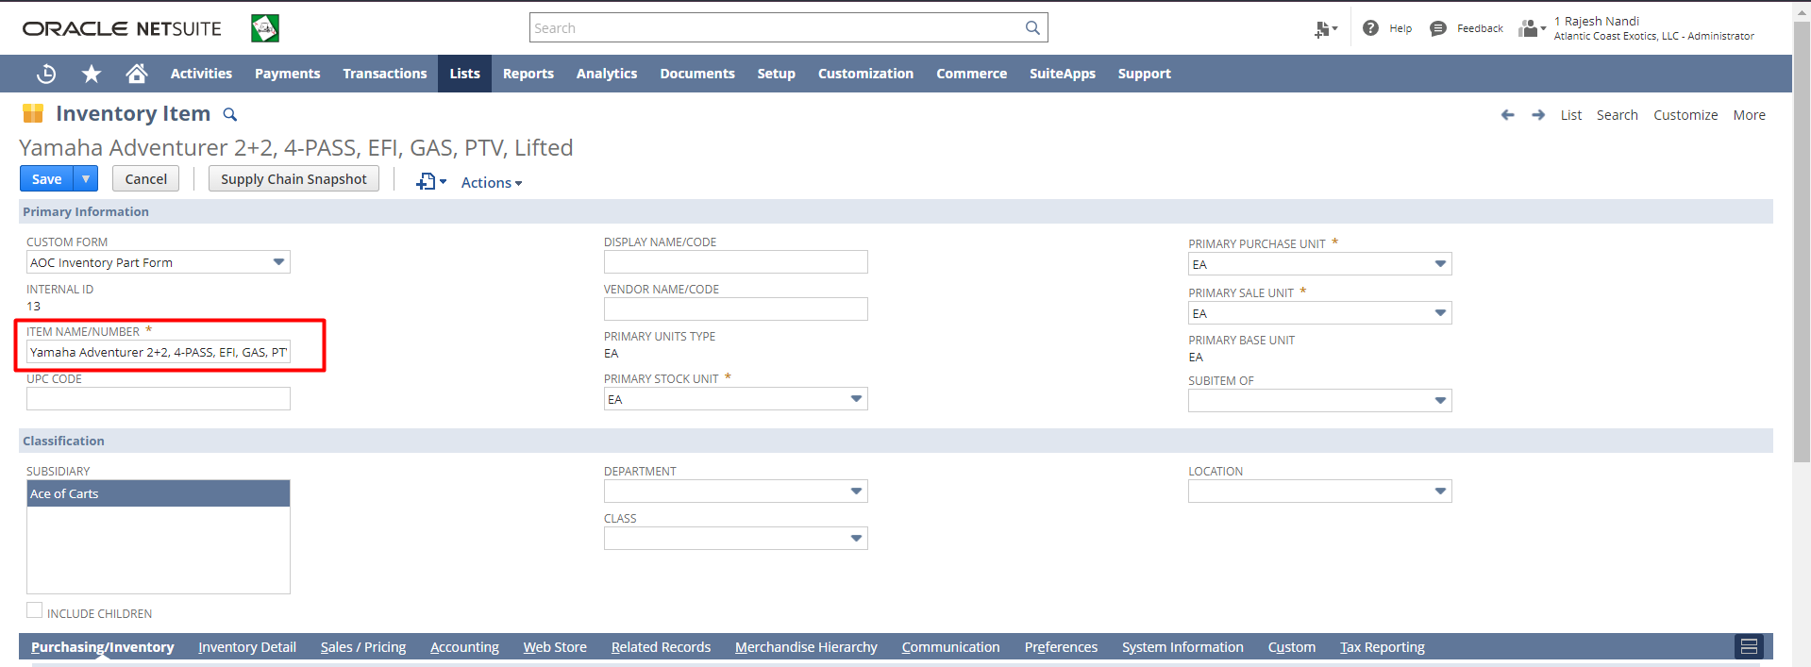
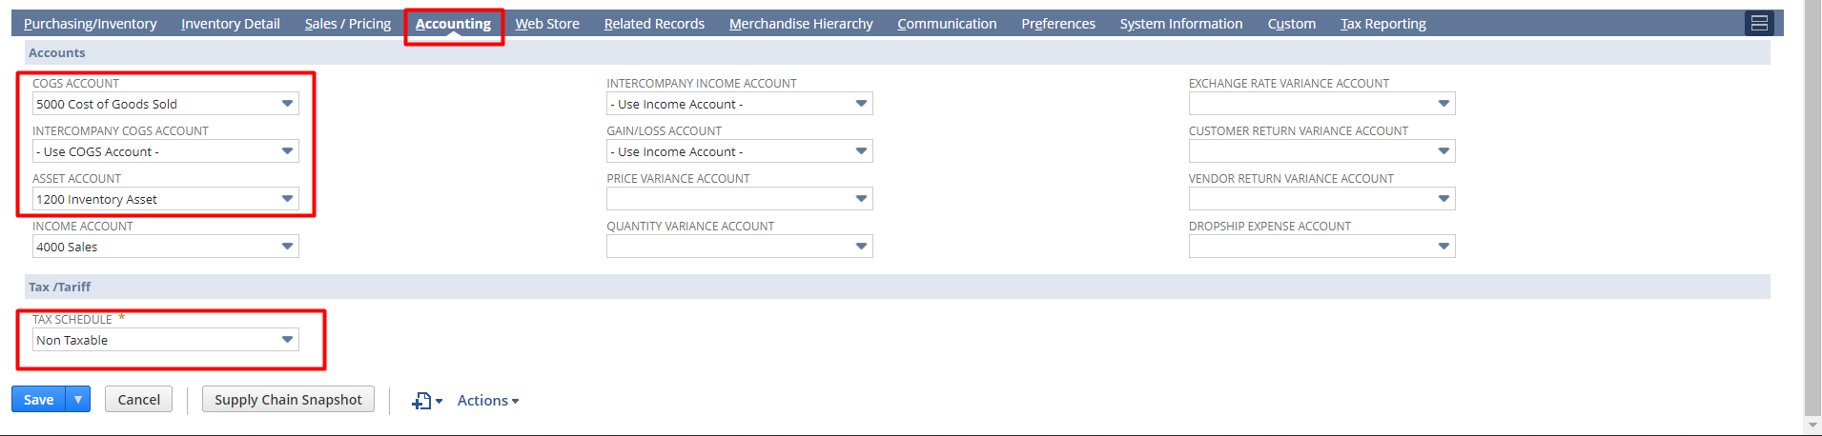
Step 4: Then click the “Save” button.

Serialized Inventory Item
With the help of serialized items, you can track the purchase and sale of physical inventory items by assigning a serial number to each item. At the time of receiving a serialized item you must enter a serial number for each serialized item. For example, if you enter a quantity of 2, then you must enter two serial numbers. Similarly, at the time of fulfilling the item you must select the serial number of the item to specify from which serial number you are shipping your inventory.
Step 1: Serialized Item creation: Navigate to Lists->Accounting->Items->New


Step 2: Click on the Serialized under Inventory
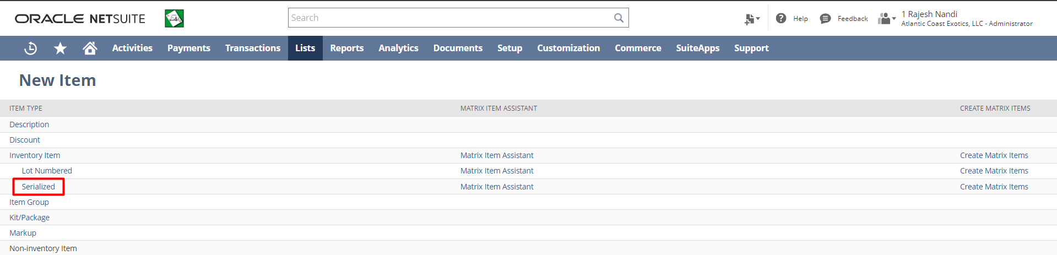

Step 3: Fill in the required details for the Serialized Inventory Item. Mandatory Fields-Item Name/Number, Tax Schedule under Accounting subtab, and other necessary details.
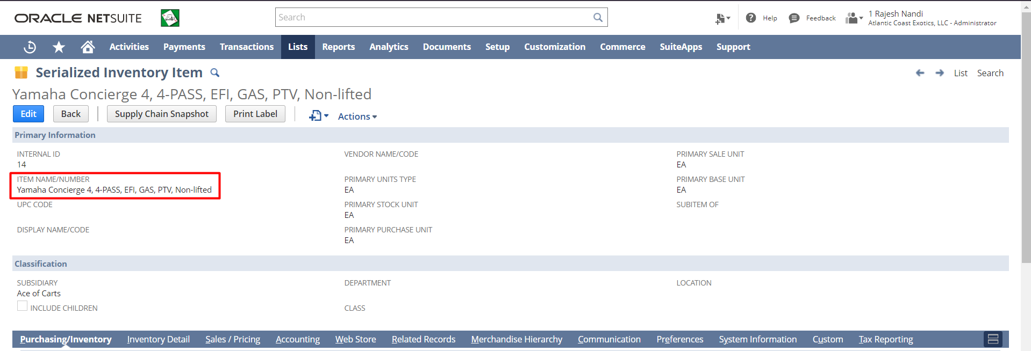

Step 4: Then click the “Save” button.

Non-Inventory Item
Items that you always dropship or other items that you sell or purchase but do not stock can be recorded and tracked as non-inventory items.
For example, you might use non-inventory items in the following ways:
- Non-inventory for Purchase – office supplies you purchase but do not sell
- Non-inventory for Sale – to sell items your custom creates for each order
- Non-inventory for Resale – drop-ship items that you do not store but you sell directly from the vendor
Non-inventory for Purchase
Step 1: Non-Inventory Item creation: Navigate to Lists->Accounting->Items->New


Step 2: Click on Sale/Purchase/Resale under Non-Inventory
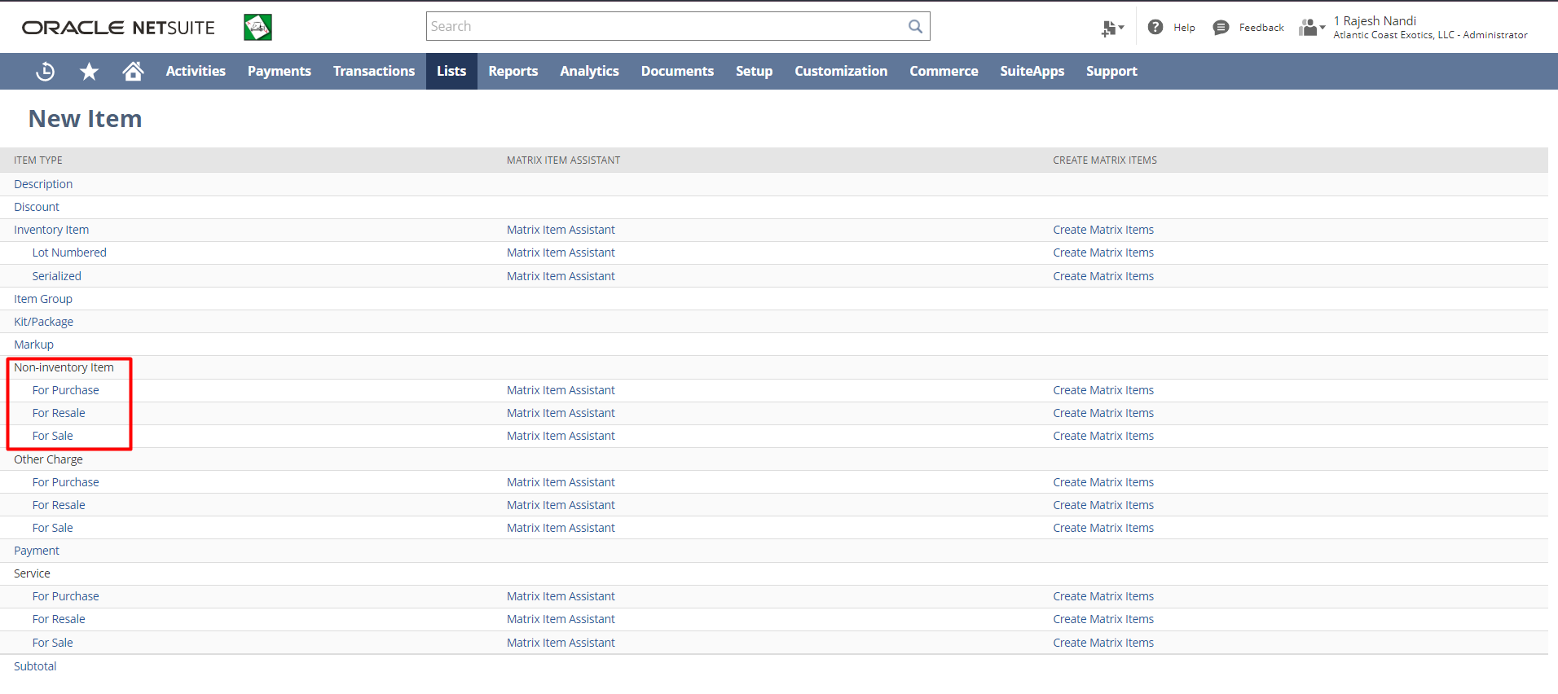
Step 3: Fill in the required details for the Non-Inventory Item. Mandatory Fields-Item Name/Number, Tax Schedule, EXPENSE ACCOUNT, INCOME ACCOUNT under Accounting subtab and put other necessary details & then click the “Save” button.
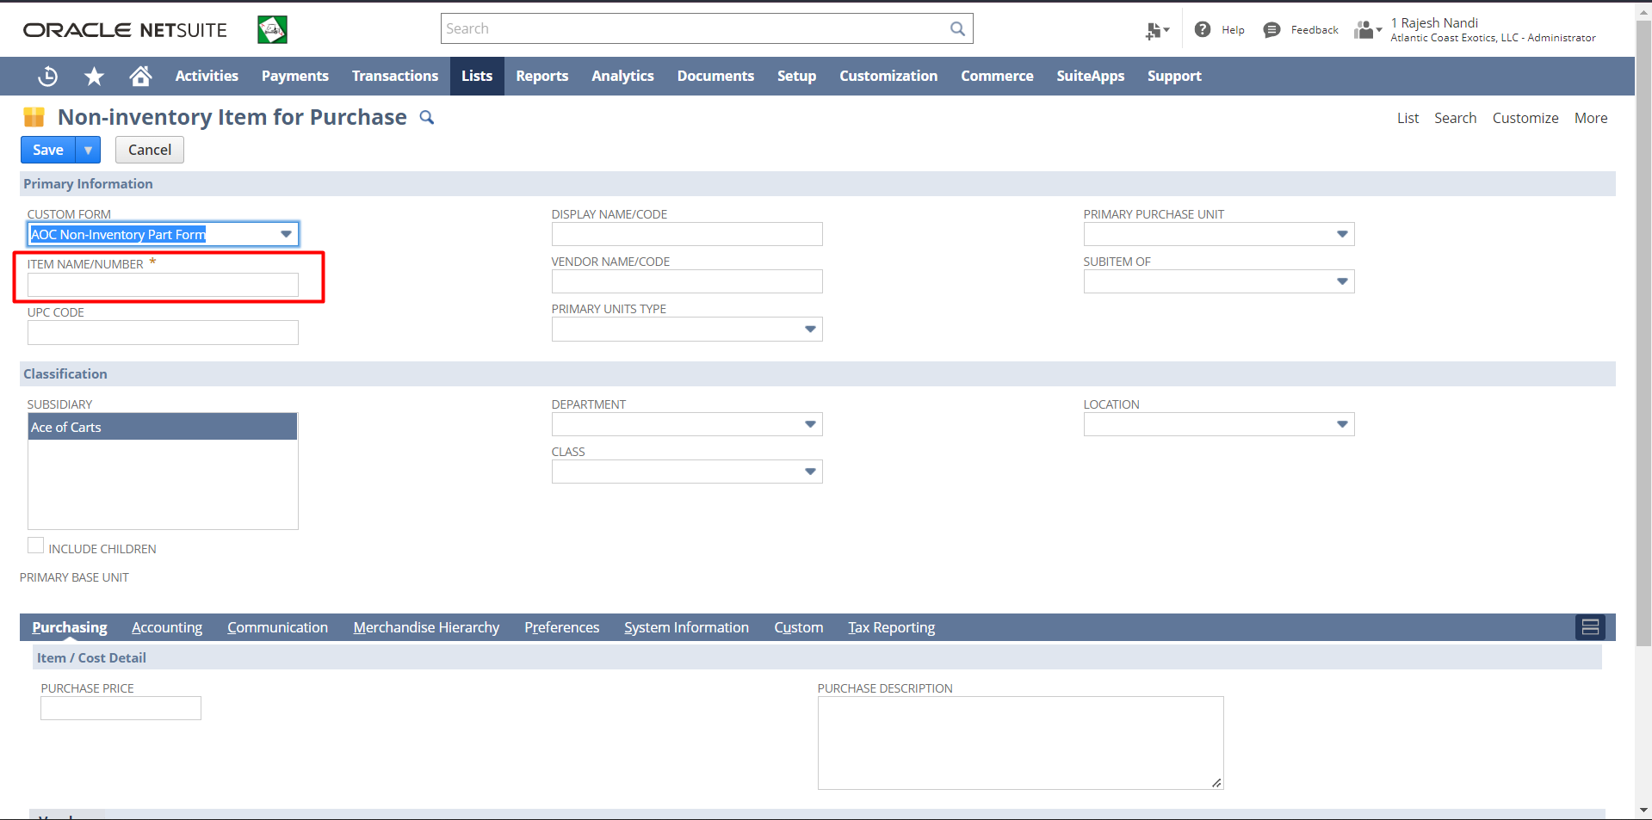
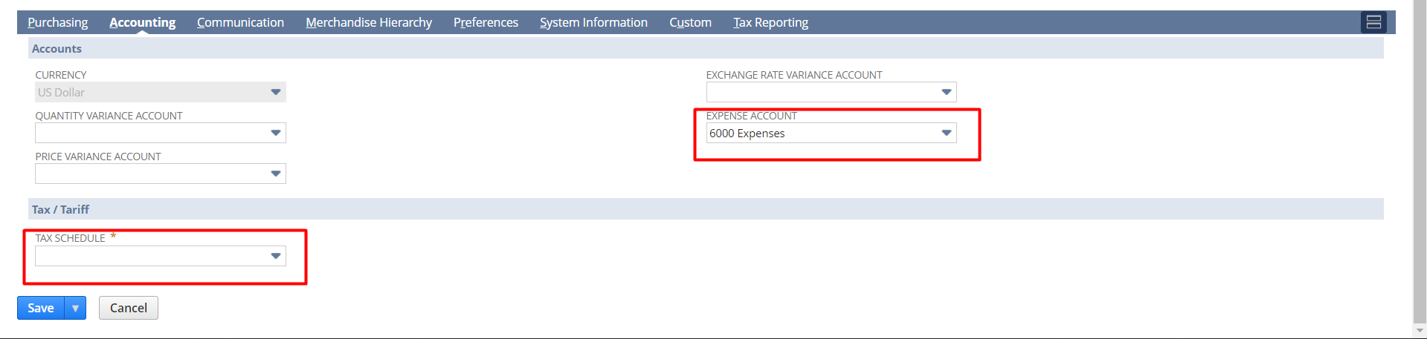
Step 4: Then click the “Save” button.

Non-inventory for Sale
Step 1: Non-Inventory Item creation: Navigate to Lists->Accounting->Items->New


Step 2: Click on Sale/Purchase/Resale under Non-Inventory.

Step 3: Fill in the required details for the Non-Inventory Item. Mandatory Fields-Item Name/Number, Tax Schedule, INCOME ACCOUNT under Accounting subtab and put other necessary details & then click the “Save” button.
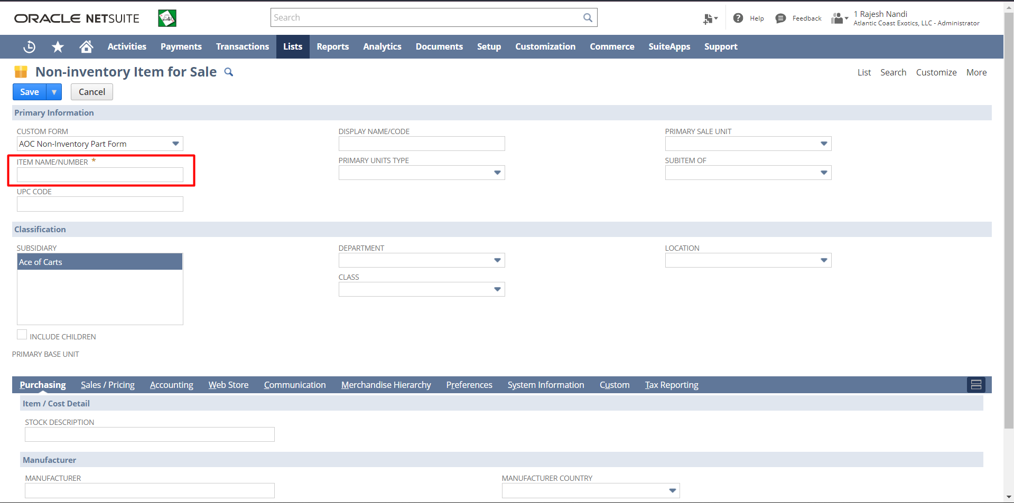

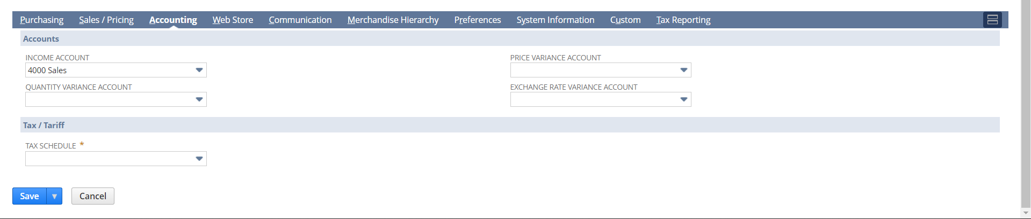
Step 4: Then click the “Save” button.

Non-inventory for Resale
Step 1: Non-Inventory Item creation: Navigate to Lists->Accounting->Items->New

Step 2: Click on Sale/Purchase/Resale under Non-Inventory.

Step 3: Fill the required details for the Non-Inventory Item. Mandatory Fields-Item Name/Number, Tax Schedule, Expense Account under Accounting subtab and put other necessary details & then click the “Save” button.
Step 4: click on save button.

Other Charge Item
Step 1: Other Charge Item creation: Navigate to Lists->Accounting->Items->New


Step 2: Click on Sale/Purchase/Resale under Other Charge Item
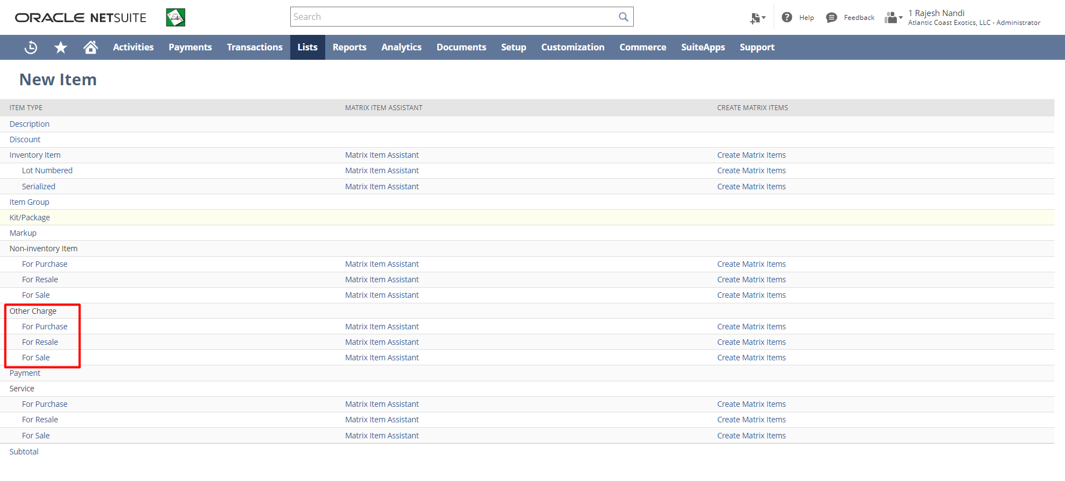
Step 3: Fill the required details for the Non-Inventory Item. Mandatory Fields-Item Name/Number, Tax Schedule under Accounting subtab and put other necessary details & then click the “Save” button.
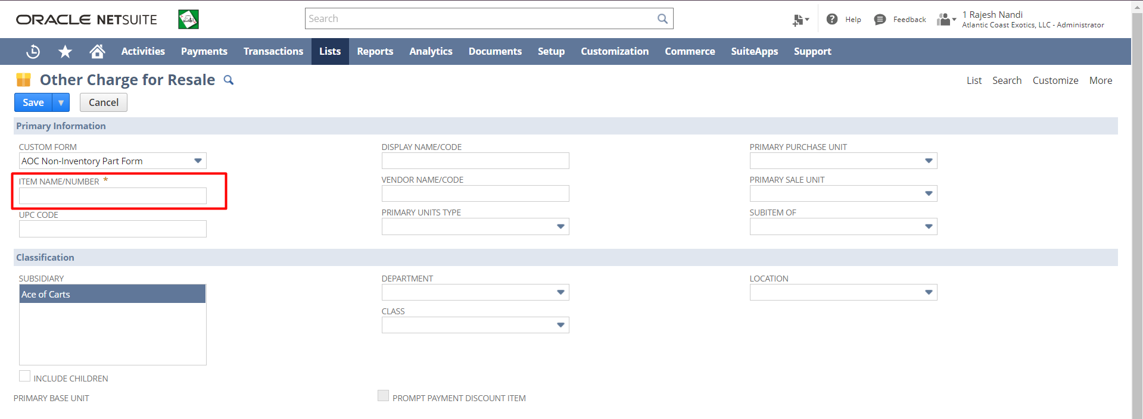
Under the Accounting tab, put ‘Income’ & ‘Expense’ Account and Tax Schedule
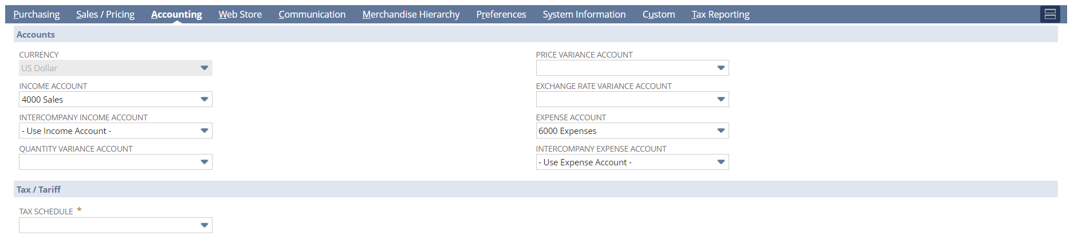
Step 4: Click on the save button.
Service Item
A service item is an item you create to track time and record billable hours.
Service items are classified as Services for Purchase, Services for Resale, or Services for Sale.
- Services for Purchase – services your business buys but doesn't sell to customers
- Services for Resale – services your business buys and then sells to customers
- Services for Sale – services your business sells but doesn't buy

1. Service for Resale: -
Step 1: Service Item creation: Navigate to Lists->Accounting->Items->New.


Step 2: Click on ‘for Resale’ under Service
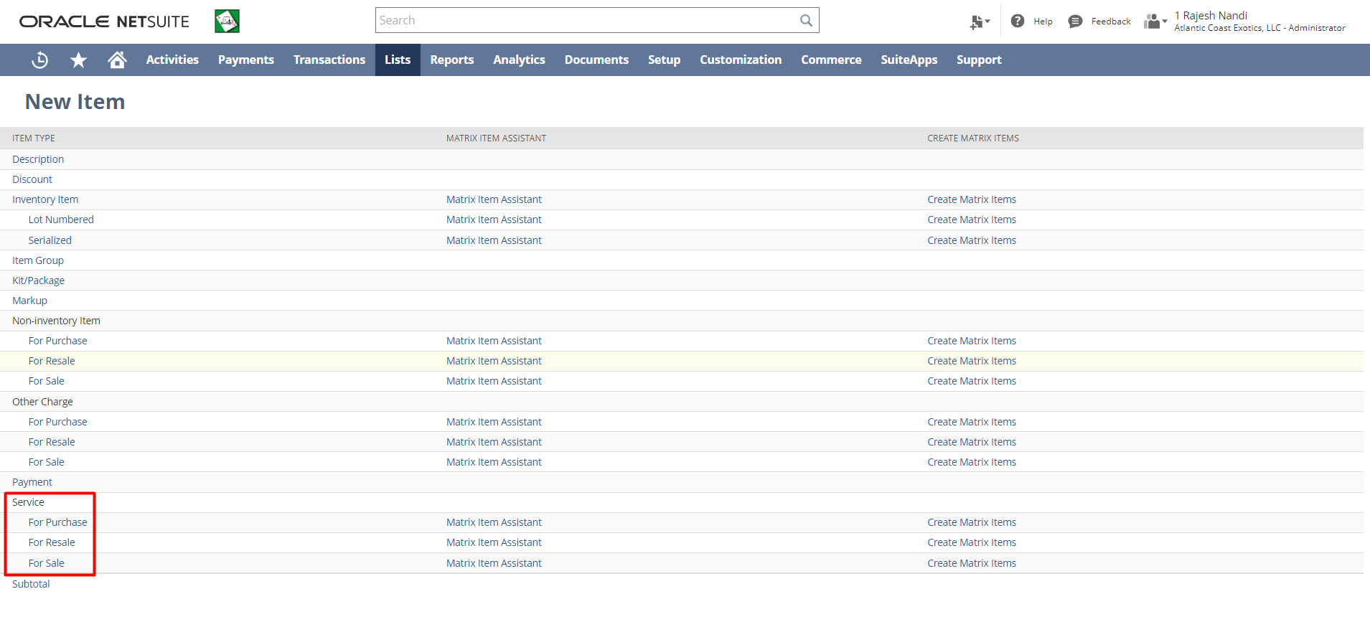

Step 3: Fill the required details for the Item. Mandatory Fields-Item Name/Number, Tax Schedule under Accounting subtab and put other necessary details & then click the “Save” button.
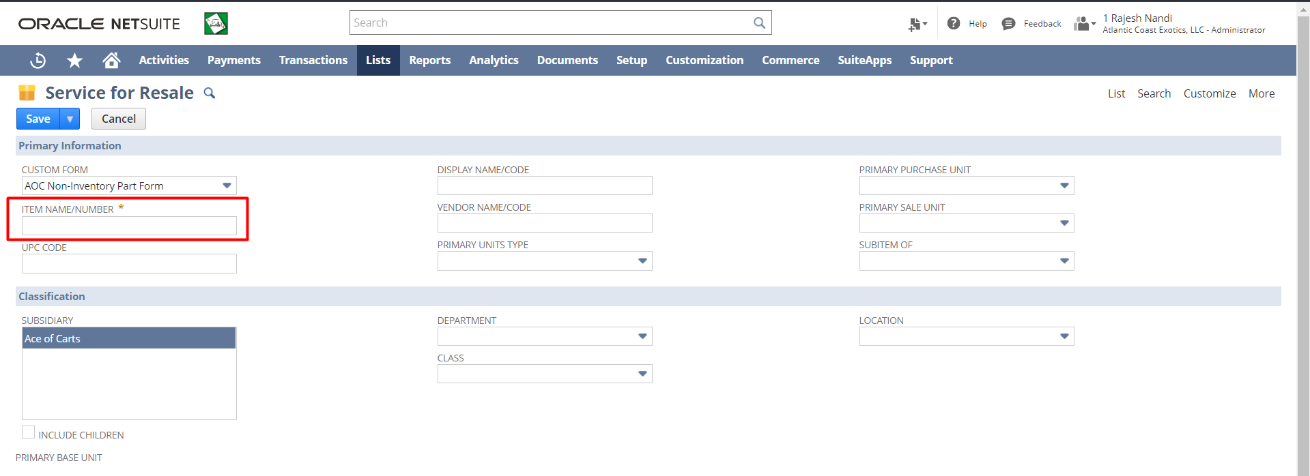
Under the Accounting tab, put ‘Income’ & ‘Expense’ Account and Tax Schedule
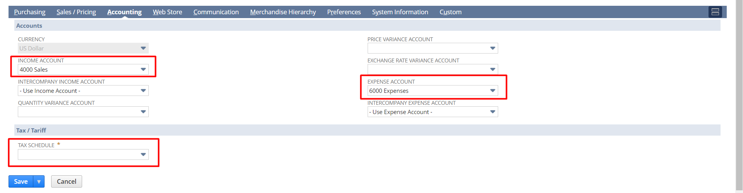
Step 4: Then click the “Save” button.

2. Service for sale: -
Step 1: Service Item creation: Navigate to Lists->Accounting->Items->New


Step 2: Click on ‘for Sale’ under Service

Step 3: Fill in the required details for the Item. Mandatory Fields-Item Name/Number, Tax Schedule under Accounting subtab and put other necessary details & then click the “Save” button.
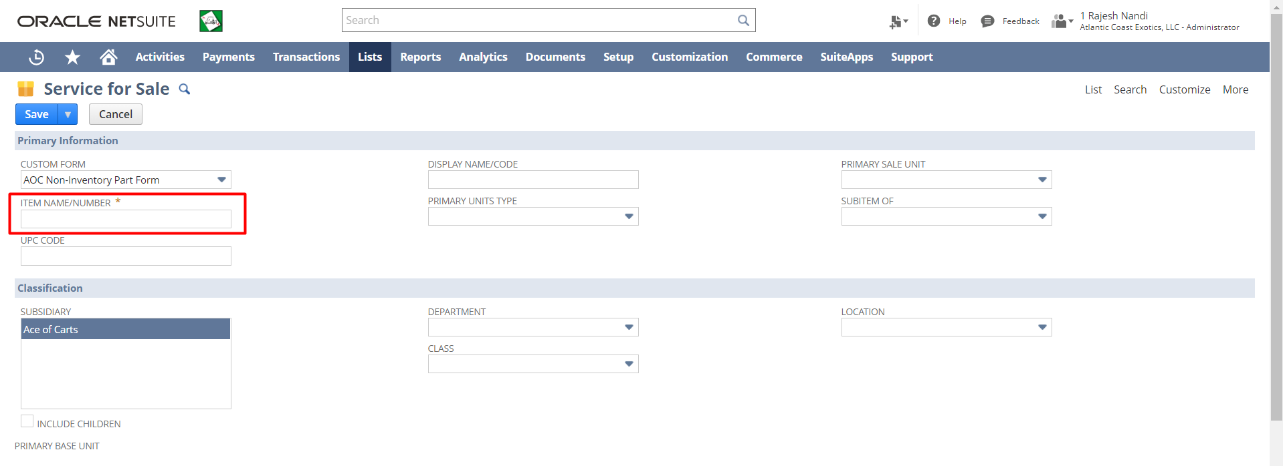
Under the Accounting tab, put ‘Income Account’ and ‘Tax Schedule’.
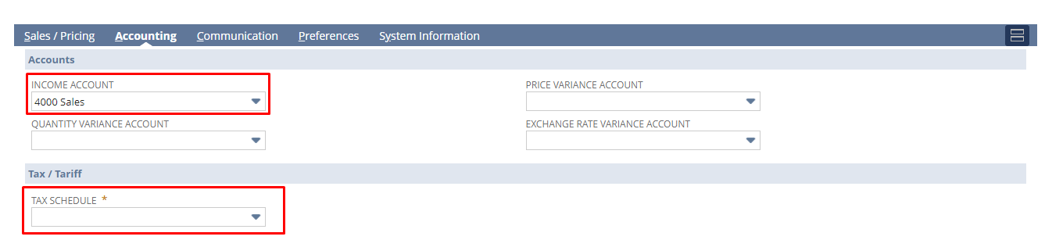
Step 4: Then click the “Save” button.

3. Service for purchase: -
Step 1: Service Item creation: Navigate to Lists->Accounting->Items->New

Step 2: Click on for ‘for Purchase’ under Service

Step 3: Fill the required details for the Item. Mandatory Fields-Item Name/Number, Tax Schedule under Accounting subtab and put other necessary details & then click the “Save” button.
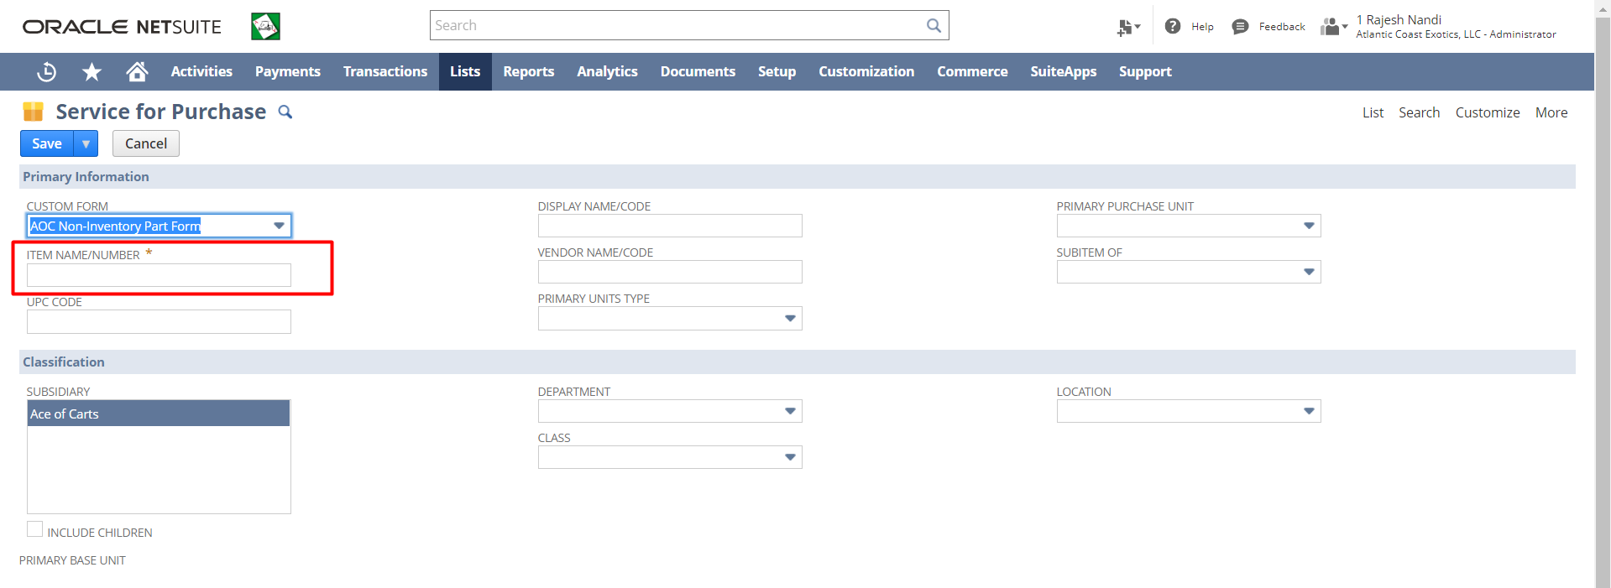
Under the Accounting tab, put ‘Expense Account’ and ‘Tax Schedule’.
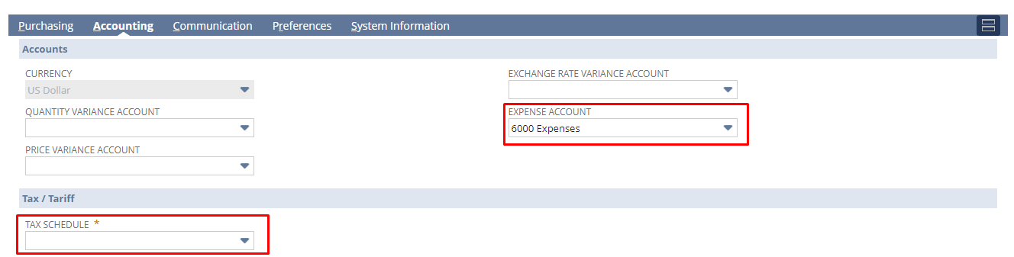
Step 4: Then click the “Save” button.

Markup Item
Markup Items to apply an additional charge to an order.
Step 1: Serialized Item creation: Navigate to Lists->Accounting->Items->New


Step 2: Click on the Markup
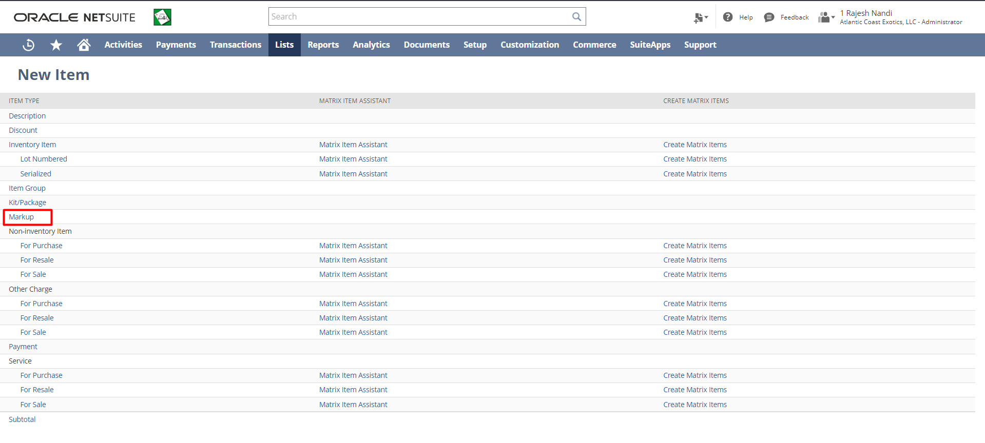

Step 3: Fill in the required details for the Serialized Inventory Item. Mandatory Fields-Item Name/Number, Tax Schedule under Accounting subtab, and other necessary details.
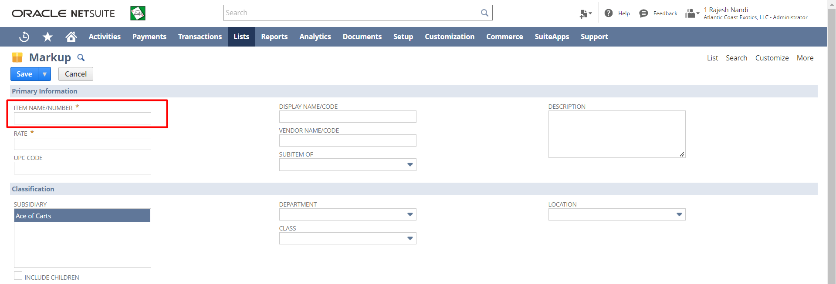

Step 4: Then click the “Save” button.

Signature: ________________________________ Date: _____________________________________
Disclaimer:
Upon signing off on the process flow document, you are confirming that the process has been set up per the SOW within NetSuite per your business's needs. Any changes or modifications requested after sign-off will need to be a "change request" at an additional fee.
*** PLEASE ensure that you have logged into NetSuite and tested the process prior to signing off on the setup. Paapri requires sign-off on this document prior to moving forward with any additional design meetings.

